UnsupLoc - A System for Infrastructure Friendly Unsupervised Indoor Localization

Avik Ghose,Chirabrata Bhaumik,Nasimuddin Ahmed,Amit Agrawal,Vivek Chandel,Abhinav Kumar,Arpan Pal
Tata Consultancy Services
CTO Innovation Lab - Systems
Rajarhat, Ecospace-1B, Kolkata, India
+91-6688-4000
{avik.ghose,c.bhaumik,nasim.ahmed,amitk.agrawal,vivek.chandel,abhinav.k3,arpan.pal}@tcs.com

ABSTRACT
Major issues in the domain of indoor localization include the amount of training required for the system to work, the cost of infrastructure and dependency on the same, and finally the sensitivity to changes in the environment. In our approach in UnsupLoc, we have used unsupervised methods for localization using WiFi based zoning and tri-literation, along with dead-reckoning from an entrance by a geo-fencing technique using magnetometer and accelerometer on user’s mobile phone and by putting a few magnets on the entry/exit gate.
Our system, named UnsupLoc, consists of an android application and server side components. The android application captures values of WiFi RSSI (Received Signal Strength Indicator), accelerometer based direction and displacement, and finally, magnetometer based entry and exit into the premise. A schematic deployment of UnsupLoc is shown in Figure 1.
As mentioned before, UnsupLoc works on a synergy of various independent methods. The major sensors being used are phone inertial sensors, magnetometer readings and WiFi RSSI values. The methods involved in unsupLoc are described hereafter.
WiFi trilateration does not provide good practical accuracy because the access points are often located behind some indoor partition with a fixed amount of attenuation. This attenuation causes the trilateration to be erroneous but the drop in signal strength can be calculated based on the type of material and the number of such partitions crossed between transmitter and receiver. In UnsupLoc, we have considered indoor enclosures to be zones and used unsupervised machine learning methods to classify user locations into zones. Finally, using the correct zone information, WiFi trilateration with known attenuation model gives accurate point-level accuracy in UnsupLoc.
A k-means clustering is done on the observed RSSI values whose median values are considered over 3-5 observations to reduce the effects of fluctuations and fed to a k-means module with k = number of zones in the premise. The output is a set of classified points.
The output of the clustering module is used to train a RSSI based decision tree. The conditions are then transformed into the distance plane using free space formula for WiFi.
The decision conditions are used to project circles on the floor plan where simple less than and greater than conditions are mapped to interior and exterior of the circles. The zone in UnsupLoc is finally decided on the basis of maximum overlap between a cluster and a physical zone.
After identifying the zone accurately, attenuation aware trilateration is done in UnsupLoc to get a rough location of the user. This is fused with inertial localization, which is based on step detection, and stride length based distance with direction estimates from both magnetometer and accelerometer.
Entry and exit to the premise in UnsupLoc is estimated by putting permanent magnets on the gate and using phone magnetometer and accelerometer to record the perturbations using CFAR peak-detection and inertial direction.
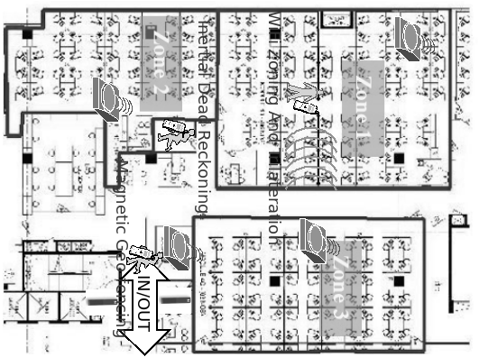
Finally the point location from various approaches is fused in UnsupLoc to arrive at the final location.
Figure 1. Schematic System Deployment in UnsupLoc

.

